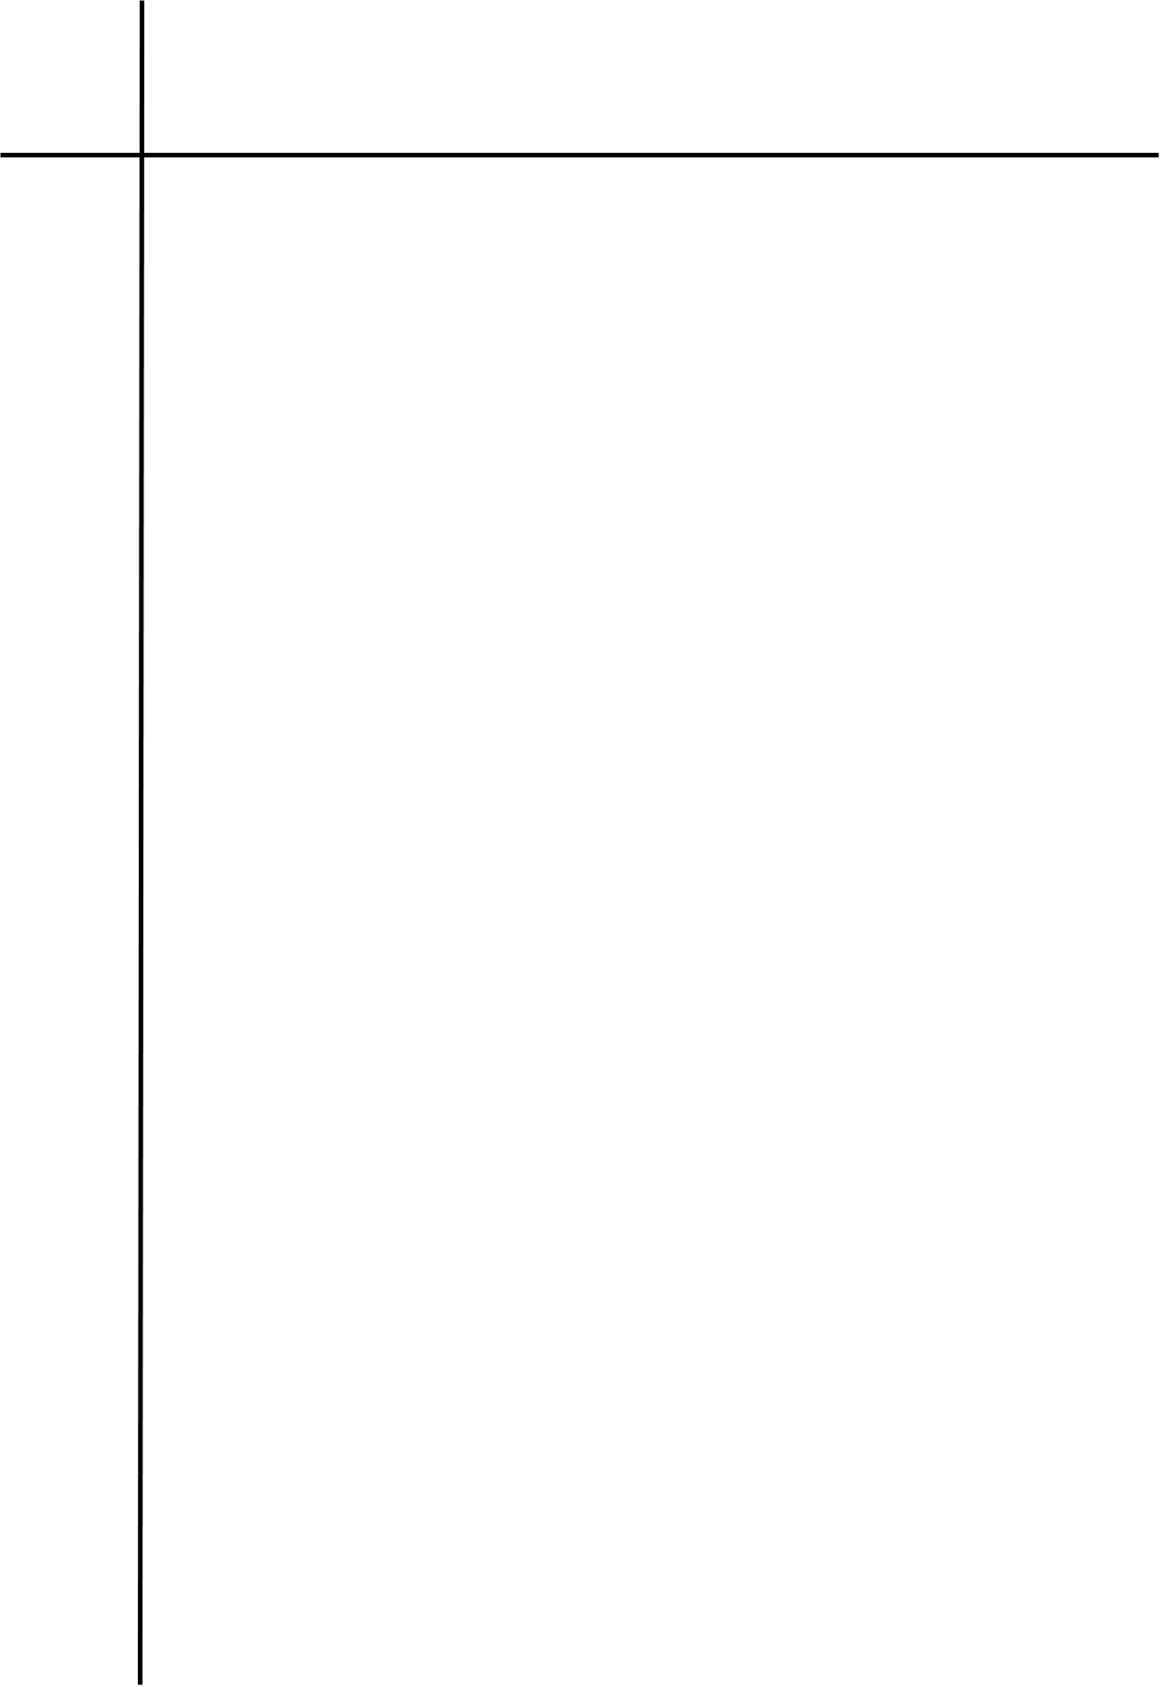
Source Code

# LAB 3.1 Implement Program that identifies valid c identifiers.
c_keywords = {"auto", "break", "case", "char", "const", "continue", "default", "do", "double", "else", "enum", "extern", "float", "for", "goto", "if", "int", "long", "register", "return", "short", "signed", "sizeof", "static", "struct", "switch", "typedef", "union", "unsigned", "void", "volatile", "while"}

str = input("Enter an identifier to check: ")

if len(str) == 0:
print("Invalid Identifier")

elif not (str[0].isalpha() or str[0] == "_"):
print("Invalid Identifier")

elif not all(ch.isalnum() or ch == "_" for ch in str):
print("Invalid Identifier")

elif str in c_keywords:
print("It is a C keyword")

else:
print("Valid identifier")




Output
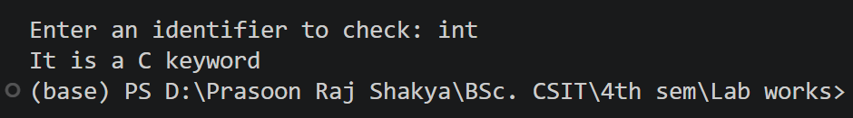
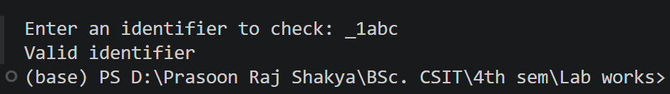

Conclusion
The program successfully identifies whether an input string is a valid C identifier. It checks starting characters, allowed characters, and reserved C keywords. Thus, the basic rules for C identifier validation are implemented successfully.

